**Mercedes Benz Online Store**

**Background**  
This project is being undertaken for customers to be able to purchase vehicles online.

This project is for customers wanting to purchase a vehicle from the safety of their own home with ease.

This project will let customers see all vehicles for sale in the dealership at once.

**Benefits**

This project will bring benefits of easy ordering and choosing of their new vehicle.

It will improve the lives of consumers by having an ease of access to buying a car.

**Key Features**

* Login with account information that’s secure
* Register new accounts
* Buy vehicles with ease

**Similar Applications**

**Etsy**

**Amazon**

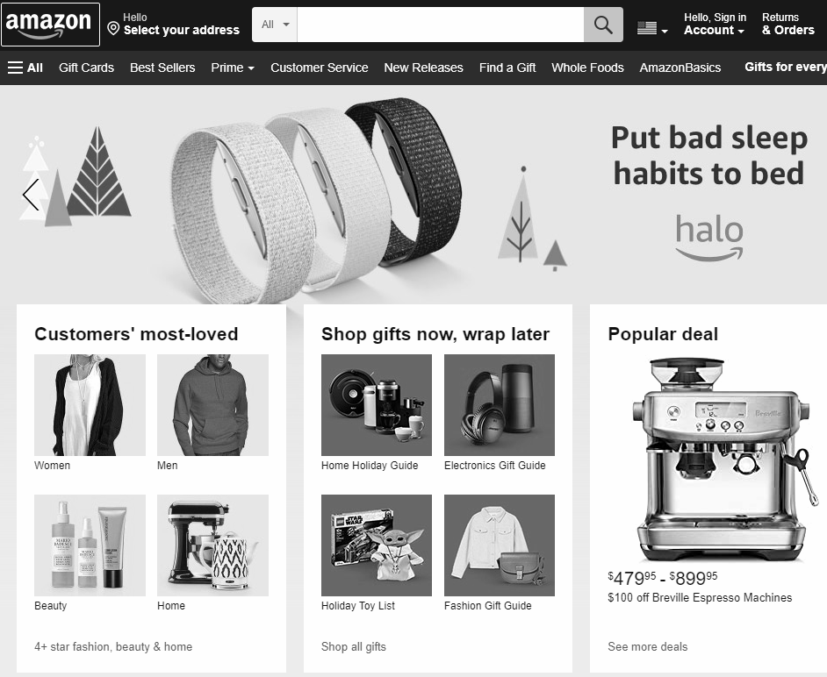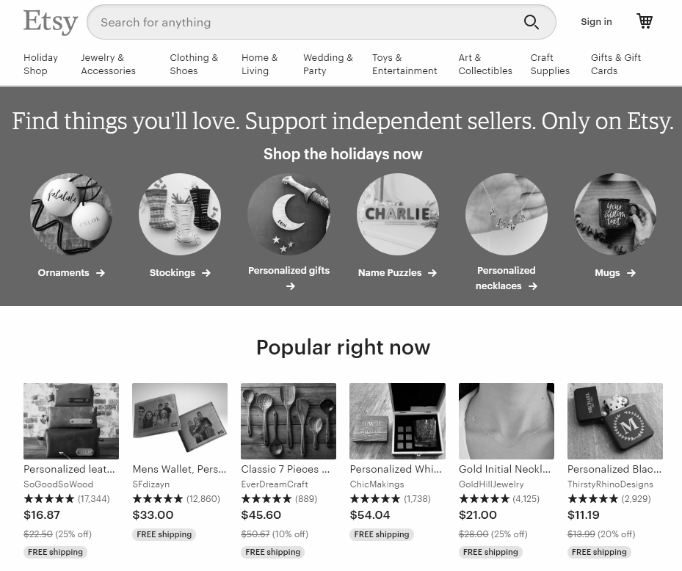

**Color Palette**

**UI Design Inspiration**

